1 run

training 1 epoch...

239.0861623287201 seconds used......

1 training finished! average train loss: 0.5981769836917687

evaluating...

Confusion matrix, without normalization

[[ 697 185 140]

[ 819 4481 107]

[1163 360 9242]]

Normalized confusion matrix

[[0.68199609 0.18101761 0.1369863 ]

[0.15147032 0.82874052 0.01978916]

[0.1080353 0.03344171 0.85852299]]

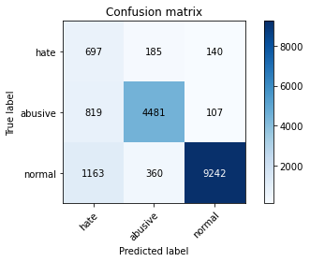

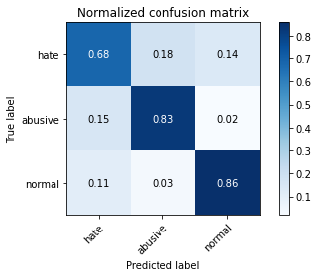

precision recall f1-score support

hate 0.26 0.68 0.38 1022

abusive 0.89 0.83 0.86 5407

normal 0.97 0.86 0.91 10765

accuracy 0.84 17194

macro avg 0.71 0.79 0.72 17194

weighted avg 0.91 0.84 0.86 17194

average eval_loss: 0.4507312701451917, accuracy: 0.8386646504594626

training 2 epoch...

238.39516925811768 seconds used......

2 training finished! average train loss: 0.4373335575949796

evaluating...

Confusion matrix, without normalization

[[ 656 131 235]

[1115 4075 217]

[ 560 269 9936]]

Normalized confusion matrix

[[0.64187867 0.12818004 0.22994129]

[0.20621417 0.75365267 0.04013316]

[0.05202044 0.02498839 0.92299118]]

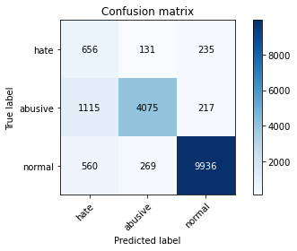

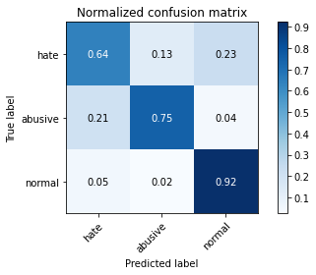

precision recall f1-score support

hate 0.28 0.64 0.39 1022

abusive 0.91 0.75 0.82 5407

normal 0.96 0.92 0.94 10765

accuracy 0.85 17194

macro avg 0.72 0.77 0.72 17194

weighted avg 0.90 0.85 0.87 17194

average eval_loss: 0.3922798741305637, accuracy: 0.8530301267884146

training 3 epoch...

238.33815741539001 seconds used......

3 training finished! average train loss: 0.32406419622407

evaluating...

Confusion matrix, without normalization

[[ 694 205 123]

[ 745 4559 103]

[1661 404 8700]]

Normalized confusion matrix

[[0.67906067 0.20058708 0.12035225]

[0.13778435 0.84316627 0.01904938]

[0.15429633 0.03752903 0.80817464]]

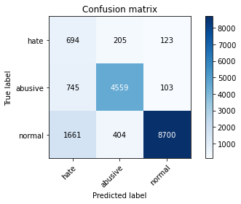

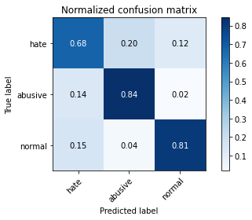

precision recall f1-score support

hate 0.22 0.68 0.34 1022

abusive 0.88 0.84 0.86 5407

normal 0.97 0.81 0.88 10765

accuracy 0.81 17194

macro avg 0.69 0.78 0.69 17194

weighted avg 0.90 0.81 0.84 17194

average eval_loss: 0.5600671508197868, accuracy: 0.8115040130278004

training 4 epoch...

238.48032760620117 seconds used......

4 training finished! average train loss: 0.21021686104162013

evaluating...

Confusion matrix, without normalization

[[ 774 177 71]

[1096 4250 61]

[2931 413 7421]]

Normalized confusion matrix

[[0.75733855 0.17318982 0.06947162]

[0.2027002 0.78601812 0.01128167]

[0.27227125 0.03836507 0.68936368]]

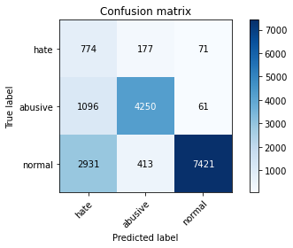

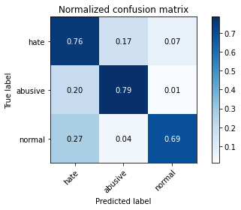

precision recall f1-score support

hate 0.16 0.76 0.27 1022

abusive 0.88 0.79 0.83 5407

normal 0.98 0.69 0.81 10765

accuracy 0.72 17194

macro avg 0.67 0.74 0.64 17194

weighted avg 0.90 0.72 0.78 17194

average eval_loss: 0.9450109860058441, accuracy: 0.7237989996510411

training 5 epoch...

238.48345732688904 seconds used......

5 training finished! average train loss: 0.1507924611177758

evaluating...

Confusion matrix, without normalization

[[ 694 183 145]

[ 957 4302 148]

[1455 425 8885]]

Normalized confusion matrix

[[0.67906067 0.17906067 0.14187867]

[0.17699279 0.79563529 0.02737193]

[0.13516024 0.0394798 0.82535996]]

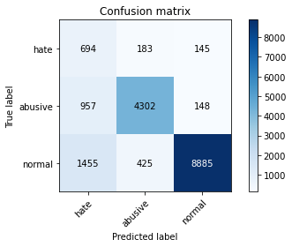

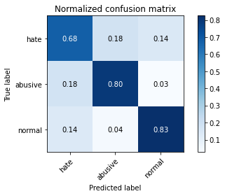

precision recall f1-score support

hate 0.22 0.68 0.34 1022

abusive 0.88 0.80 0.83 5407

normal 0.97 0.83 0.89 10765

accuracy 0.81 17194

macro avg 0.69 0.77 0.69 17194

weighted avg 0.89 0.81 0.84 17194

average eval_loss: 0.6921386826350245, accuracy: 0.8073165057578225

2 run

training 1 epoch...

238.57343339920044 seconds used......

1 training finished! average train loss: 0.6030819105913623

evaluating...

Confusion matrix, without normalization

[[ 693 185 144]

[ 725 4550 132]

[1161 313 9291]]

Normalized confusion matrix

[[0.67808219 0.18101761 0.1409002 ]

[0.13408544 0.84150176 0.0244128 ]

[0.10784951 0.02907571 0.86307478]]

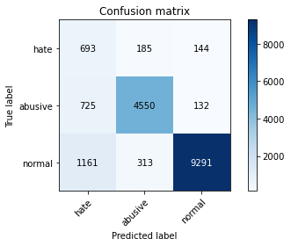

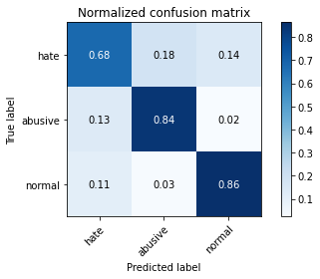

precision recall f1-score support

hate 0.27 0.68 0.38 1022

abusive 0.90 0.84 0.87 5407

normal 0.97 0.86 0.91 10765

accuracy 0.85 17194

macro avg 0.71 0.79 0.72 17194

weighted avg 0.91 0.85 0.87 17194

average eval_loss: 0.43448768426166023, accuracy: 0.8452948703035943

training 2 epoch...

238.58224773406982 seconds used......

2 training finished! average train loss: 0.4397557355614871

evaluating...

Confusion matrix, without normalization

[[ 750 137 135]

[1093 4172 142]

[1341 284 9140]]

Normalized confusion matrix

[[0.73385519 0.13405088 0.13209393]

[0.20214537 0.77159238 0.02626225]

[0.12457037 0.02638179 0.84904784]]

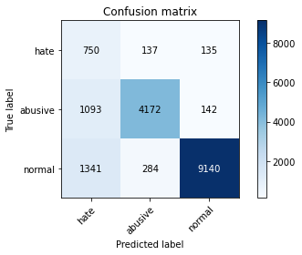

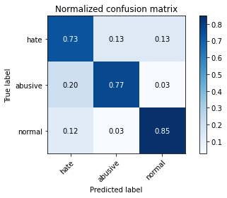

precision recall f1-score support

hate 0.24 0.73 0.36 1022

abusive 0.91 0.77 0.83 5407

normal 0.97 0.85 0.91 10765

accuracy 0.82 17194

macro avg 0.70 0.78 0.70 17194

weighted avg 0.91 0.82 0.85 17194

average eval_loss: 0.4888696629813937, accuracy: 0.8178434337559614

training 3 epoch...

238.6762375831604 seconds used......

3 training finished! average train loss: 0.3163594196531627

evaluating...

Confusion matrix, without normalization

[[ 570 268 184]

[ 532 4703 172]

[ 800 404 9561]]

Normalized confusion matrix

[[0.55772994 0.26223092 0.18003914]

[0.09839097 0.86979841 0.03181062]

[0.07431491 0.03752903 0.88815606]]

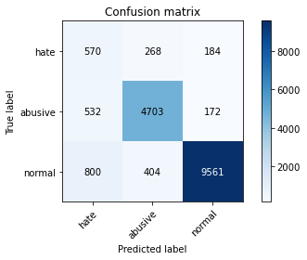

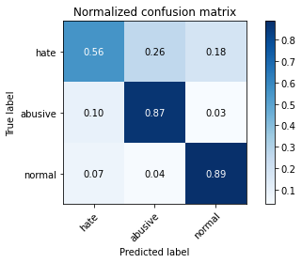

precision recall f1-score support

hate 0.30 0.56 0.39 1022

abusive 0.87 0.87 0.87 5407

normal 0.96 0.89 0.92 10765

accuracy 0.86 17194

macro avg 0.71 0.77 0.73 17194

weighted avg 0.90 0.86 0.88 17194

average eval_loss: 0.4416291603688584, accuracy: 0.8627428172618355

training 4 epoch...

238.66546487808228 seconds used......

4 training finished! average train loss: 0.20340060213954939

evaluating...

Confusion matrix, without normalization

[[ 699 197 126]

[1040 4238 129]

[1848 369 8548]]

Normalized confusion matrix

[[0.68395303 0.1927593 0.12328767]

[0.19234326 0.78379878 0.02385796]

[0.17166744 0.03427775 0.79405481]]

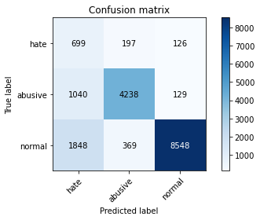

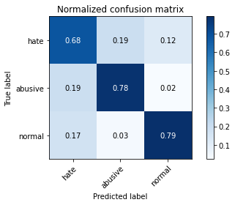

precision recall f1-score support

hate 0.19 0.68 0.30 1022

abusive 0.88 0.78 0.83 5407

normal 0.97 0.79 0.87 10765

accuracy 0.78 17194

macro avg 0.68 0.75 0.67 17194

weighted avg 0.90 0.78 0.83 17194

average eval_loss: 0.7546550755670597, accuracy: 0.7842852157729441

training 5 epoch...

238.73998165130615 seconds used......

5 training finished! average train loss: 0.14197673160965402

evaluating...

Confusion matrix, without normalization

[[ 721 189 112]

[1060 4235 112]

[1924 340 8501]]

Normalized confusion matrix

[[0.70547945 0.18493151 0.10958904]

[0.19604217 0.78324394 0.02071389]

[0.17872736 0.03158384 0.78968881]]

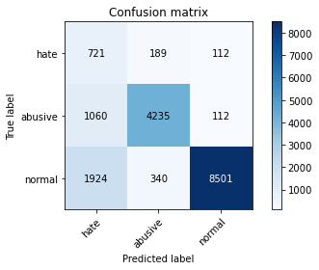

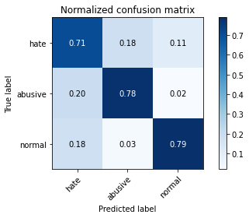

precision recall f1-score support

hate 0.19 0.71 0.31 1022

abusive 0.89 0.78 0.83 5407

normal 0.97 0.79 0.87 10765

accuracy 0.78 17194

macro avg 0.69 0.76 0.67 17194

weighted avg 0.90 0.78 0.83 17194

average eval_loss: 0.9456693664886231, accuracy: 0.7826567407235082

3 run

training 1 epoch...

238.75576639175415 seconds used......

1 training finished! average train loss: 0.6120878315738846

evaluating...

Confusion matrix, without normalization

[[ 659 178 185]

[ 766 4481 160]

[ 810 331 9624]]

Normalized confusion matrix

[[0.64481409 0.1741683 0.18101761]

[0.14166821 0.82874052 0.02959127]

[0.07524385 0.03074779 0.89400836]]

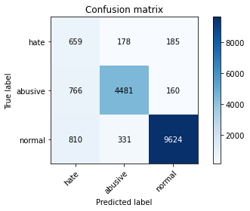

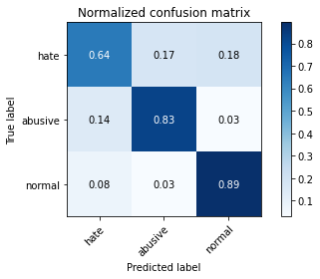

precision recall f1-score support

hate 0.29 0.64 0.40 1022

abusive 0.90 0.83 0.86 5407

normal 0.97 0.89 0.93 10765

accuracy 0.86 17194

macro avg 0.72 0.79 0.73 17194

weighted avg 0.90 0.86 0.88 17194

average eval_loss: 0.40530927999075067, accuracy: 0.858671629638246

training 2 epoch...

238.5503306388855 seconds used......

2 training finished! average train loss: 0.442230361578965

evaluating...

Confusion matrix, without normalization

[[ 767 124 131]

[1167 4106 134]

[1475 241 9049]]

Normalized confusion matrix

[[0.75048924 0.12133072 0.12818004]

[0.21583133 0.75938598 0.02478269]

[0.13701811 0.02238737 0.84059452]]

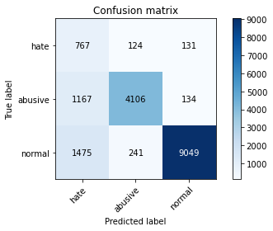

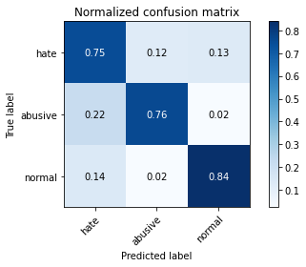

precision recall f1-score support

hate 0.22 0.75 0.35 1022

abusive 0.92 0.76 0.83 5407

normal 0.97 0.84 0.90 10765

accuracy 0.81 17194

macro avg 0.70 0.78 0.69 17194

weighted avg 0.91 0.81 0.85 17194

average eval_loss: 0.5054120241209518, accuracy: 0.8097010585087822

training 3 epoch...

238.7183656692505 seconds used......

3 training finished! average train loss: 0.31899943522284857

evaluating...

Confusion matrix, without normalization

[[ 634 212 176]

[ 674 4549 184]

[1013 327 9425]]

Normalized confusion matrix

[[0.62035225 0.2074364 0.17221135]

[0.12465323 0.84131681 0.03402996]

[0.09410125 0.03037622 0.87552253]]

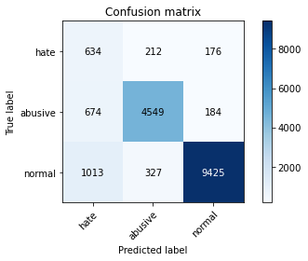

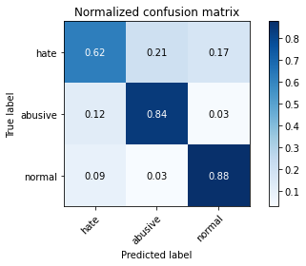

precision recall f1-score support

hate 0.27 0.62 0.38 1022

abusive 0.89 0.84 0.87 5407

normal 0.96 0.88 0.92 10765

accuracy 0.85 17194

macro avg 0.71 0.78 0.72 17194

weighted avg 0.90 0.85 0.87 17194

average eval_loss: 0.46573113736285027, accuracy: 0.8495986972199604

training 4 epoch...

238.5635392665863 seconds used......

4 training finished! average train loss: 0.2077352113592907

evaluating...

Confusion matrix, without normalization

[[ 625 253 144]

[ 605 4678 124]

[1425 419 8921]]

Normalized confusion matrix

[[0.61154599 0.24755382 0.1409002 ]

[0.11189199 0.86517477 0.02293323]

[0.13237343 0.03892243 0.82870413]]

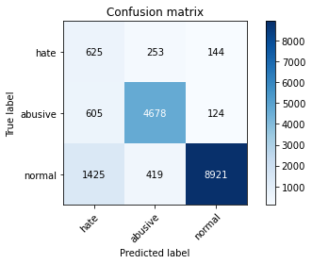

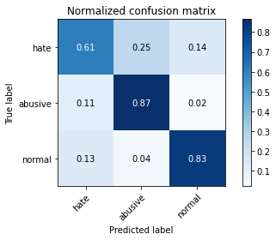

precision recall f1-score support

hate 0.24 0.61 0.34 1022

abusive 0.87 0.87 0.87 5407

normal 0.97 0.83 0.89 10765

accuracy 0.83 17194

macro avg 0.69 0.77 0.70 17194

weighted avg 0.90 0.83 0.85 17194

average eval_loss: 0.5626551580831929, accuracy: 0.8272653251134117

training 5 epoch...

238.63125014305115 seconds used......

5 training finished! average train loss: 0.1306415876998034

evaluating...

Confusion matrix, without normalization

[[ 670 186 166]

[ 956 4302 149]

[1263 418 9084]]

Normalized confusion matrix

[[0.6555773 0.18199609 0.16242661]

[0.17680784 0.79563529 0.02755687]

[0.11732466 0.03882954 0.8438458 ]]

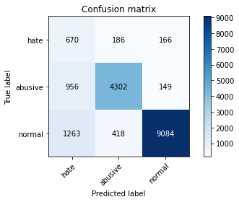

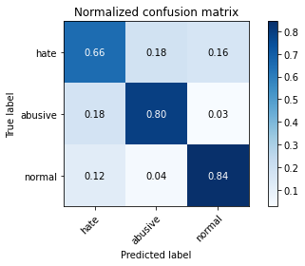

precision recall f1-score support

hate 0.23 0.66 0.34 1022

abusive 0.88 0.80 0.83 5407

normal 0.97 0.84 0.90 10765

accuracy 0.82 17194

macro avg 0.69 0.77 0.69 17194

weighted avg 0.89 0.82 0.85 17194

average eval_loss: 0.7201750516090109, accuracy: 0.8174944748167966

4 run

training 1 epoch...

238.42308139801025 seconds used......

1 training finished! average train loss: 0.6150230453864716

evaluating...

Confusion matrix, without normalization

[[ 707 177 138]

[ 788 4483 136]

[1399 313 9053]]

Normalized confusion matrix

[[0.69178082 0.17318982 0.13502935]

[0.14573701 0.82911041 0.02515258]

[0.1299582 0.02907571 0.84096609]]

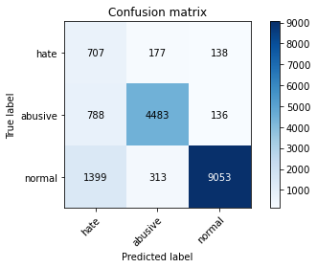

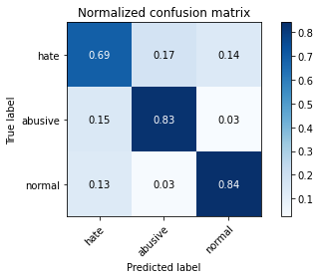

precision recall f1-score support

hate 0.24 0.69 0.36 1022

abusive 0.90 0.83 0.86 5407

normal 0.97 0.84 0.90 10765

accuracy 0.83 17194

macro avg 0.71 0.79 0.71 17194

weighted avg 0.91 0.83 0.86 17194

average eval_loss: 0.5100681400922842, accuracy: 0.8283703617541003

training 2 epoch...

238.54742670059204 seconds used......

2 training finished! average train loss: 0.44424811422690313

evaluating...

Confusion matrix, without normalization

[[ 693 192 137]

[ 778 4513 116]

[1225 384 9156]]

Normalized confusion matrix

[[0.67808219 0.18786693 0.13405088]

[0.14388755 0.83465878 0.02145367]

[0.11379471 0.03567116 0.85053414]]

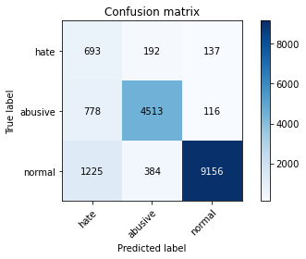

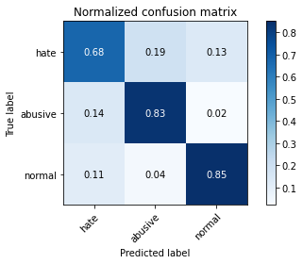

precision recall f1-score support

hate 0.26 0.68 0.37 1022

abusive 0.89 0.83 0.86 5407

normal 0.97 0.85 0.91 10765

accuracy 0.84 17194

macro avg 0.71 0.79 0.71 17194

weighted avg 0.90 0.84 0.86 17194

average eval_loss: 0.4679354531213988, accuracy: 0.8352913807142026

training 3 epoch...

238.67331528663635 seconds used......

3 training finished! average train loss: 0.3279002636721522

evaluating...

Confusion matrix, without normalization

[[ 696 195 131]

[ 746 4536 125]

[1403 377 8985]]

Normalized confusion matrix

[[0.68101761 0.19080235 0.12818004]

[0.1379693 0.83891252 0.02311818]

[0.13032977 0.0350209 0.83464933]]

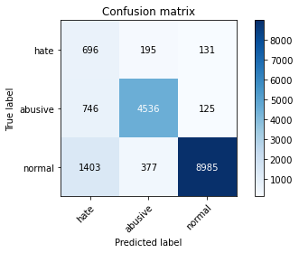

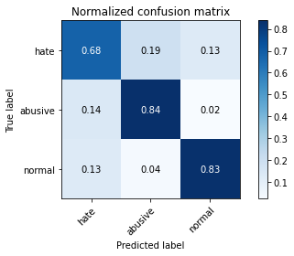

precision recall f1-score support

hate 0.24 0.68 0.36 1022

abusive 0.89 0.84 0.86 5407

normal 0.97 0.83 0.90 10765

accuracy 0.83 17194

macro avg 0.70 0.78 0.71 17194

weighted avg 0.90 0.83 0.86 17194

average eval_loss: 0.5271036149370809, accuracy: 0.8268582063510527

training 4 epoch...

238.60861444473267 seconds used......

4 training finished! average train loss: 0.21350423762108078

evaluating...

Confusion matrix, without normalization

[[ 575 202 245]

[ 819 4311 277]

[ 618 286 9861]]

Normalized confusion matrix

[[0.56262231 0.19765166 0.23972603]

[0.15147032 0.7972998 0.05122989]

[0.05740827 0.02656758 0.91602415]]

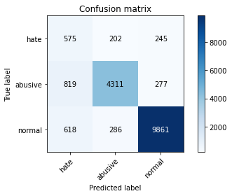

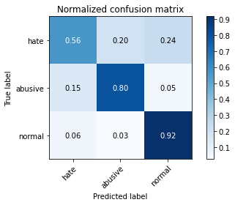

precision recall f1-score support

hate 0.29 0.56 0.38 1022

abusive 0.90 0.80 0.84 5407

normal 0.95 0.92 0.93 10765

accuracy 0.86 17194

macro avg 0.71 0.76 0.72 17194

weighted avg 0.89 0.86 0.87 17194

average eval_loss: 0.5056595454274049, accuracy: 0.8576829126439456

training 5 epoch...

238.91798639297485 seconds used......

5 training finished! average train loss: 0.14276490613616347

evaluating...

Confusion matrix, without normalization

[[ 713 206 103]

[ 923 4389 95]

[2089 390 8286]]

Normalized confusion matrix

[[0.69765166 0.20156556 0.10078278]

[0.17070464 0.81172554 0.01756982]

[0.19405481 0.03622852 0.76971667]]

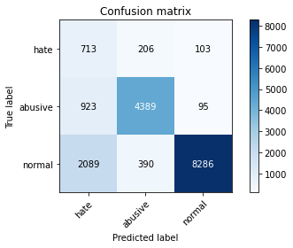

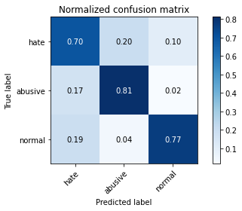

precision recall f1-score support

hate 0.19 0.70 0.30 1022

abusive 0.88 0.81 0.84 5407

normal 0.98 0.77 0.86 10765

accuracy 0.78 17194

macro avg 0.68 0.76 0.67 17194

weighted avg 0.90 0.78 0.82 17194

average eval_loss: 0.8979834610856203, accuracy: 0.7786437129231127

5 run

training 1 epoch...

238.36321306228638 seconds used......

1 training finished! average train loss: 0.6158169520426012

evaluating...

Confusion matrix, without normalization

[[ 682 198 142]

[ 717 4565 125]

[1153 397 9215]]

Normalized confusion matrix

[[0.66731898 0.19373777 0.13894325]

[0.13260588 0.84427594 0.02311818]

[0.10710636 0.03687877 0.85601486]]

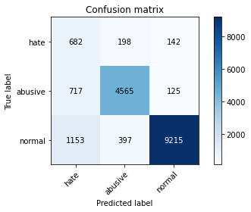

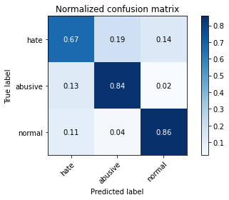

precision recall f1-score support

hate 0.27 0.67 0.38 1022

abusive 0.88 0.84 0.86 5407

normal 0.97 0.86 0.91 10765

accuracy 0.84 17194

macro avg 0.71 0.79 0.72 17194

weighted avg 0.90 0.84 0.86 17194

average eval_loss: 0.45711241711017697, accuracy: 0.8411073630336163

training 2 epoch...

237.7238552570343 seconds used......

2 training finished! average train loss: 0.4434018538041255

evaluating...

Confusion matrix, without normalization

[[ 711 159 152]

[ 989 4294 124]

[1090 340 9335]]

Normalized confusion matrix

[[0.69569472 0.1555773 0.14872798]

[0.18291104 0.79415572 0.02293323]

[0.10125406 0.03158384 0.8671621 ]]

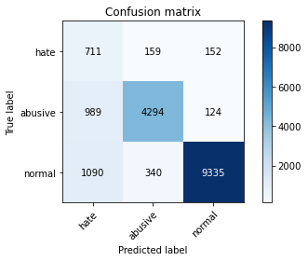

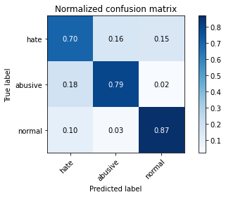

precision recall f1-score support

hate 0.25 0.70 0.37 1022

abusive 0.90 0.79 0.84 5407

normal 0.97 0.87 0.92 10765

accuracy 0.83 17194

macro avg 0.71 0.79 0.71 17194

weighted avg 0.90 0.83 0.86 17194

average eval_loss: 0.4582809878123361, accuracy: 0.8340118646039316

training 3 epoch...

237.97498178482056 seconds used......

3 training finished! average train loss: 0.3196903430177719

evaluating...

Confusion matrix, without normalization

[[ 683 194 145]

[ 765 4527 115]

[1453 435 8877]]

Normalized confusion matrix

[[0.66829746 0.18982387 0.14187867]

[0.14148326 0.83724801 0.02126873]

[0.13497445 0.04040873 0.82461681]]

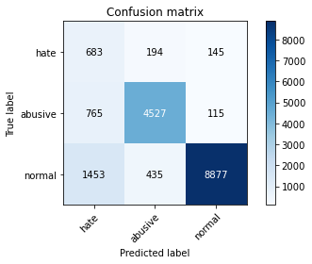

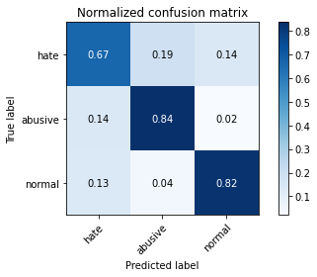

precision recall f1-score support

hate 0.24 0.67 0.35 1022

abusive 0.88 0.84 0.86 5407

normal 0.97 0.82 0.89 10765

accuracy 0.82 17194

macro avg 0.69 0.78 0.70 17194

weighted avg 0.90 0.82 0.85 17194

average eval_loss: 0.5189642756311006, accuracy: 0.8192974293358148

training 4 epoch...

237.7443721294403 seconds used......

4 training finished! average train loss: 0.21361975785151427

evaluating...

Confusion matrix, without normalization

[[ 734 160 128]

[1229 4071 107]

[2143 294 8328]]

Normalized confusion matrix

[[0.71819961 0.15655577 0.12524462]

[0.22729795 0.75291289 0.01978916]

[0.19907106 0.02731073 0.77361821]]

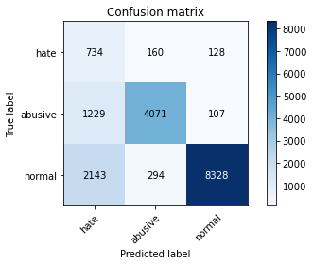

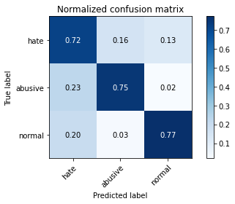

precision recall f1-score support

hate 0.18 0.72 0.29 1022

abusive 0.90 0.75 0.82 5407

normal 0.97 0.77 0.86 10765

accuracy 0.76 17194

macro avg 0.68 0.75 0.66 17194

weighted avg 0.90 0.76 0.81 17194

average eval_loss: 0.7594749660079563, accuracy: 0.7638129580086076

training 5 epoch...

237.99615240097046 seconds used......

5 training finished! average train loss: 0.14228376321826744

evaluating...

Confusion matrix, without normalization

[[ 746 147 129]

[1203 4064 140]

[1572 335 8858]]

Normalized confusion matrix

[[0.72994129 0.14383562 0.12622309]

[0.22248937 0.75161827 0.02589236]

[0.1460288 0.03111937 0.82285183]]

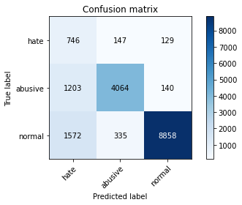

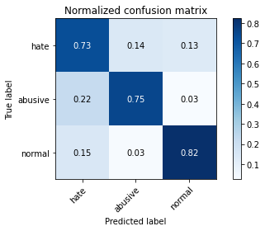

precision recall f1-score support

hate 0.21 0.73 0.33 1022

abusive 0.89 0.75 0.82 5407

normal 0.97 0.82 0.89 10765

accuracy 0.79 17194

macro avg 0.69 0.77 0.68 17194

weighted avg 0.90 0.79 0.83 17194

average eval_loss: 0.829222418346204, accuracy: 0.7949284634174713